**Assignment -3**

Python Programming

|  |  |
| --- | --- |
| Assignment Date | 19 September 2022 |
| Student Name | Nisha M K |
| Maximum Marks | 2 Marks |

**Question-1:**

Download the dataset: Dataset

**Solution:**

https://drive.google.com/file/d/1xkynpL15pt6KT3YSlDimu4A5iRU9qYck/view

**Question-2:**

Image Augmentation. **Solution:**

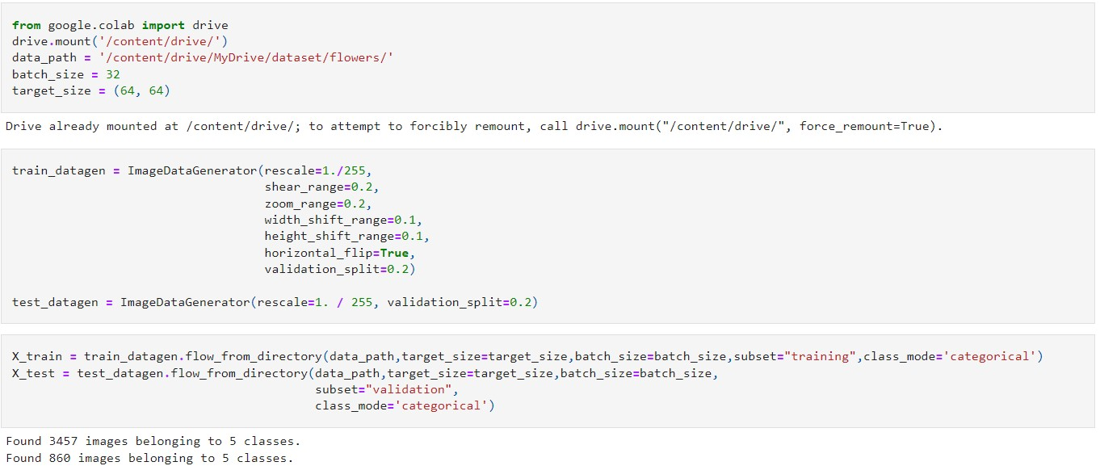

**Question-3:**

Create Model **Solution:**



**Question-4:**

**Add Layers (Convolution, MaxPooling, Flatten, Dense-(Hidden Layers),Output) Solution:**

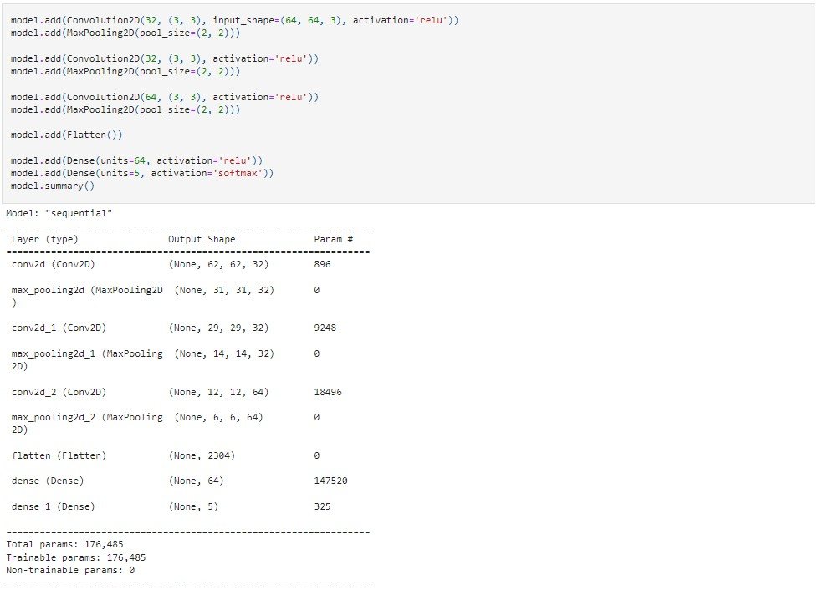

**Question-5:**

**Compile The Model Solution:**



**Question-6:**

**Fit The Model Solution:**

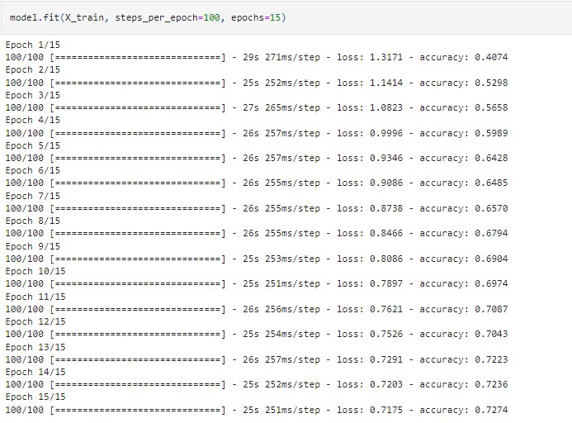

**Question-7:**

**Save The Model Solution:**



**Question-8:**

**Test The Model Solution:**

